
Business Analysis Use Case Specification

Table of Contents
Overview 2
Use Case Specification Sections 2
Using the Use Case Specification Template 2
Use Case Specification Summary 3
Basic Flow 3
Alternate Flow(s) 4
Business Rule(s) 4
Business Data Catalogue 4
User Interface(s) 5
Notifications 5
Additional Details & Notes 6

Overview
The Business Analysis Use Case Specification Template is intended to provide business analysts working on RPA initiatives with the structure and guidance to define detailed requirements, specifications, and models necessary to complete Requirements. A Use Case Specification describes the system interaction between an actor/robot and the solution in the process of achieving a goal.

Use Case Specification Sections
- Use Case Specification Summary (Mandatory)
- Basic Flow (Mandatory)
- Alternate Flow(s)
- Business Rule(s) (Mandatory)
- Business Data Catalogue (Mandatory)
- Notification(s)
- User Interface(s) (Mandatory)
- Report Table(s)
- Additional Details

Using the Use Case Specification Template
The Use Case Specification provides the highest amount of granularity and detail for each process to be automated in future state. When using the Use Case Specification:
- Create a single Use Case Specification for each Process Activity
- Save each Use Case Specification following the Best Practice Standards defined.
- Embed each Use Case Specification as a file within the Requirements Template .

Use Case Specification Summary
The Use Case Specification provides the highest amount of granularity and detail for each process to be automated in future state. The summary section defines the focus of this use case specification, actors, conditions, and trace to L3 process.

Use Case Name | Automated Management of Prescription
Use Case Unique Identifier | AMP-001
L3 Process Map Trace
Use Case Description | The use case entails automating the management of prescriptions, allowing for seamless processing, and tracking of prescriptions from creation to fulfillment. This includes digitizing prescription data, managing prescription requests, verifying patient information, and coordinating with pharmacies for dispensing medications.
Actors
Primary: | Healthcare Providers
Secondary: | Patients, Pharmacists
Conditions
Pre-Conditions: |  | Post-Conditions:
Physician can log in and access dashboard. Patient already has an existing profile with up-to-date health history and required demographic fields. |  | Prescription is successfully processed and fulfilled, and relevant parties are notified accordingly.

Basic Flow
The set of steps performed by the actor and the solution during the execution of the use case. The basic flow represents the shortest or simplest successful path that accomplishes the goal of the actor/robot.

 | Step | Alternative Flow | UI/Notification
1 | Physician selects “Create Prescription” tab from system dashboard | AF01 - Physician selects patient profile and creates prescription in profile under “prescriptions” tab
2 | Physician selects patient name in drop down menu on prescription form. DOB, patient address PHN # will auto populate | AF02 – Demographic fields are not auto-populated, and physician must manually populate all requited fields | if patient profile is missing demographics, system error “missing information”
3 | Physician fills in prescription form including name of prescription, dosage, repeats, instructions for use | AF03 – All fields are auto-populated if it is a repeat prescription | if prescription form is missing a field, system error “missing information.”
4 | System validates the prescription is compatible for patient use based on health history that is saved in their profile |  | System displays an error message indicating  “potential risk to patient” and prompts for corrective action.
5 | Physician saves and uploads completed prescription to patient file
6 | Physician selects “preferred pharmacies” tab in patient profile and enters information for patients preferred pharmacy (name, full address, telephone number and fax number) | AF04 – Physician selects “Pharmacy” tab from dashboard and adds pharmacy to master list.
7 | Physician saves preferred pharmacy information once validated to confirm the pharmacy can receive e-prescriptions. Master list also gets updated if the pharmacy information was created in patient profile
8 | Physician goes back to "prescription history” tab in patient profile and can enable or disable updates pertaining to prescription processing - I.e. update patient when pharmacy has received/ processed prescriptions, when it is time for a refill
9 | Physician selects which pharmacy to send prescription using dropdown menu
10 | Physician saves pharmacy information which will auto-populate to prescription
11 | Physician goes back to dashboard and selects “send prescription” tab. Physician can view all prescriptions created that day and transmit all in a single batch | AF05 – Physician can transmit prescription directly from patient profile at the time of appointment
12 | Physician transmits e-prescription to pharmacy
13 | Physician receives confirmation that prescription has been successfully received by the pharmacy |  | “Prescription successfully received”
14 | Patient requests refill from patient portal and receives confirmation once approval is received and refill is successfully transmitted to preferred pharmacy |  | “Refill successfully submitted”

Alternate Flow(s)
Alternative flows describe any other paths that may be followed to allow the actor to successfully achieve the goal of the use case. Exception flows describe the desired response by the solution when the goal is unachievable, and the use case cannot be
successfully completed. Replicate this table for each Alternate/Exception flow derived from the Basic Flow.
AF Name & ID |  | (AF01 – AF05)
 | Step |  | Alternative Flow | UI/Notification
1 | Physician selects “Create Prescription” tab from system dashboard |  | AF01 - Physician selects patient profile and creates prescription in profile under “prescriptions” tab
2 | Physician selects patient name in drop down menu on form, DOB, patient address PHN # will auto populate |  | AF02 – Demographic fields are not auto-populated, and physician must manually populate all requited fields | if patient profile is missing demographics, system error “missing information”
3 | Physician fills in prescription form including name of prescription, dosage, repeats, instructions for use |  | AF03 – All fields are auto-populated if it is a repeat prescription | if prescription form is missing a field, system error “missing information”
5 | Physician selects “pharmacies” tab in patient profile and enters information for patients preferred pharmacy (name, full address, telephone number and fax number) |  | AF04 – Physician selects “Pharmacy” tab from dashboard and adds pharmacy to master list.
11 | Physician goes back to dashboard and selects “send prescription” tab. Physician can view all prescriptions created that day and transmit all in a single batch |  | AF05 – Physician can transmit prescription directly from patient profile at the time of appointment

Business Rule(s)
Business Rules define the criteria for behavior, decision making, and logic to be realized in the solution.
BR ID | Rule Name | Rule Type | Description | Step  (In Use Case)
BR001 | Auto-populate | definitional | System should auto-populate patient information to permit creation of the prescription.  System should auto-populate prescription information if it is a repeat.  Preferred pharmacy information should be auto-populated once saved and selected. | 2  3  10
BR002 | Verification | definitional | System should verify accuracy of prescription and ensure there are no medication errors that may cause adverse effects. | 4
BR003 | Transmission | behavioral | Prescription should seamlessly be transmitted to patients preferred pharmacy with no errors.  Patient should be able to request refills with easy transmission process. | 12  14
BR004 | Confirmation | definitional | Patient should be able to confirm when pharmacy has received prescription to determine the projected pick-up date/ time | 13, 14

Business Data Catalogue
The Business Data Catalogue refers to business knowledge used in the process of achieving the Use Case goal.

 | Business Term | Business Term Definition | Existing/ New | Business/ Formatting Rules | Business Term Example | Step(s)  (In Use Case)
BD001 | Prescription | A written order from a healthcare provider to a pharmacist to dispense a specific medication to a patient. | Existing | Must adhere to regulatory standards, including mandatory data elements. | Rx  Tab. Ibuprofen 200mg  1 Tablet SOS. | 1, 3, 4, 5, 11, 12
BD002 | Patient Profile | A comprehensive record containing demographic information, medical history, and other relevant details of a patient. | Existing | Must contain all the necessary patient details, Medical Histories, etc. with numeric indicating a unique patient identification. | Pt number –45654  John Doe, Date of Birth: 01/01/1980, Address: 123 Main Street, City: Toronto  Province: Ontario Zip: 12345 | 2, 6, 8, 9, 10
BD003 | Notification | A message or alert sent to inform relevant parties about a specific event or action. |  | Must be concise, clear, and delivered through preferred channels according to user preferences. | Email notification sent to the physician confirming successful transmission of a prescription. | 13, 14
BD004 | Refill | The act of requesting additional doses of a medication after the initial prescription has been consumed. |  | Must include patient identification, medication details, and preferred pharmacy information for accurate and efficient processing | Refill request for Ibuprofen | 14
BD005 | Master List | A centralized record containing comprehensive information, often used for reference or management purposes. |  | Must Include all the relevant data for easy navigation throughout different sections including drug list, pharmacy list, etc. | Master list of preferred pharmacies including names, addresses, and contact information. | 7
BD006 | Pharmacy | A facility licensed to dispense medications to patients. |  | Must include name, address, telephone number, and fax number in standardized formats for accuracy and interoperability. | Walgreens Pharmacy, 789 Elm Street, Toronto, ON.  Ph no. +1 415 857 9471. | 6, 9, 10, 12

User Interface(s)
User Interface Specifications describes the content presentation (screens, forms, navigation) the solution uses in the process of achieving the Use Case goal.
Summary of User Interfaces
UI ID | UI Name | UI Description | Step(s)  (In Use Case)
UI001 | Dashboard | Dashboard should display all relevant tabs to care including patient profile, pharmacies, prescription creation form and e-prescription transmission | 1, 6, 11
UI002 | Patient Profile | Patient profile should have all required demographic fields completed, and display tabs including charts, health history, prescription history, preferred pharmacies | 1, 6, 8, 14
UI003 | Prescription Creation Form | Form should display all relevant fields to prescription creation and permit prescription verification | 2,3,4,5
UI004 | New Pharmacy Information | Form should display all relevant fields to adding a new pharmacy to the system | 6,7
UI005 | Append Preferred Pharmacy to Patient Profile | Display should allow physician to add a new preferred pharmacy and view other preferred pharmacies that have previously been selected for patient | 9, 10
UI006 | Prescription History | Displays all prescriptions for a patient including those which have not been transmitted and those which have been. Permits Physician to add a preferred pharmacy to the newly created prescription. | 8
UI007 | Prescription Transmission | Display should permit physician to view all prescriptions created for that day, and transmit all pending prescriptions in one batch | 11,12, 13
UI008 | Patient Refill Request | Display should permit patients to request a refill based on their prescription history and receive status notifications regarding the prescription processing | 14

User Interface Specification – Screen or Mock-Up
Create a separate table for each Screen or Mock-Up within the Use Case. A screen refers to an existing interface, where as a mock-up is a representation of a new interface.

UI ID | UI001 | UI/ Screen Name: |  | Dashboard
UI Description |  | Dashboard should display all relevant tabs to care including patient profile, pharmacies, prescription creation form and e-prescription transmission.
UI Screen | 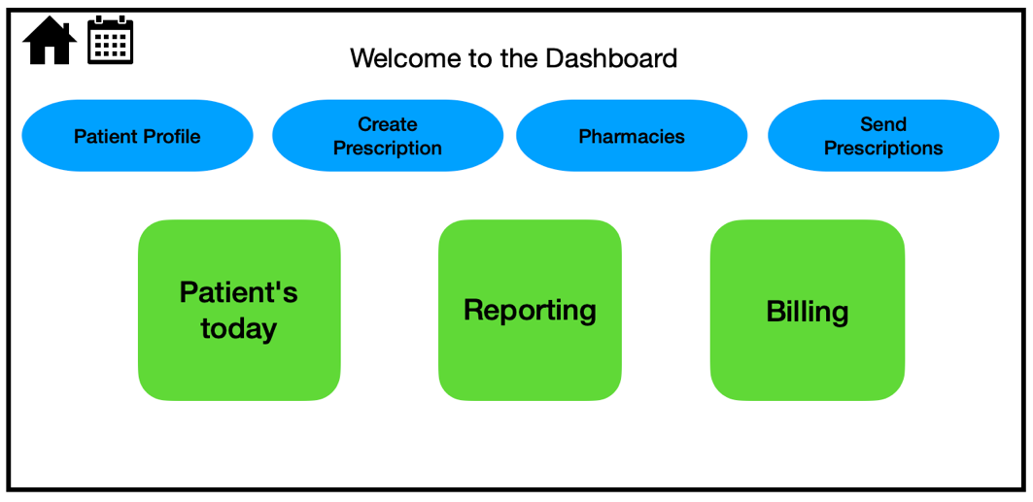
Component ID | Component Name | Data Element ID | Type | Displayed/ Enabled Rules | Label
CO001 | Patient Profile | BD002 | Button | Always Displayed | Patient Profile label
CO002 | Create Prescription | BD001 | Button | Always Displayed | Create Prescription label.
CO003 | Pharmacies |  | Button | Always Displayed | Pharmacies label
CO004 | Send Prescription | BD001 | Button | Always Displayed | Send Prescription label
CO005 | Patients today |  | Button | Always Displayed | Patients today label
CO006 | Reporting |  | Button | Always Displayed | Reporting label
CO007 | Billing |  | Button | Always Displayed | Billing label
CO008 | Home |  | Button | Always Displayed | Home label
CO009 | Calendar |  | Button | Always Displayed | Calendar label

UI ID | UI002 | UI/ Screen Name: |  | Patient Profile
UI Description |  | Patient profile should have all required demographic fields completed, and display tabs including charts, health history, prescription history, preferred pharmacies
UI Screen | 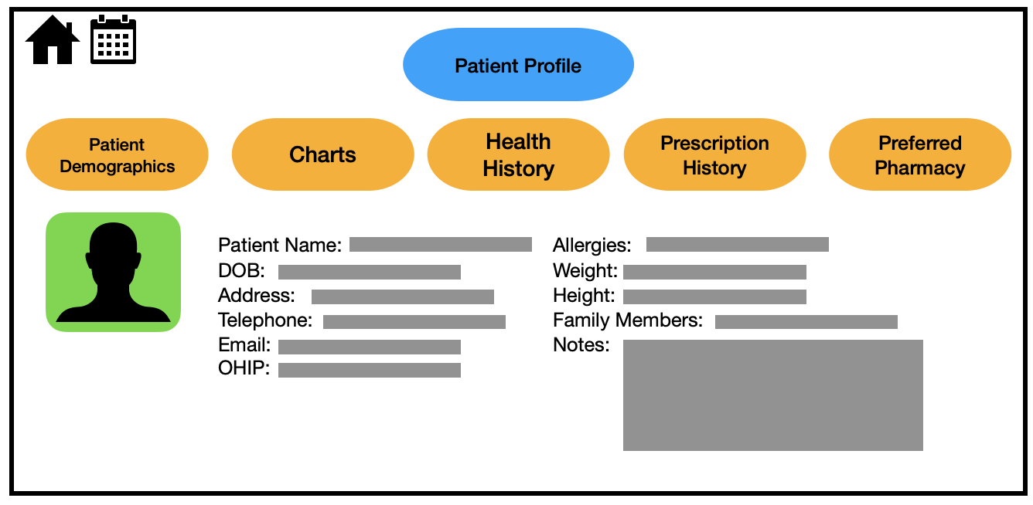
Component ID | Component Name | Data Element ID | Type | Displayed/ Enabled Rules | Label
CO001 | Charts | BD002 | Button | Always Displayed | Charts label
CO002 | Health History | BD002 | Button | Always Displayed | Health History label
CO003 | Prescription History | BD002 | Button | Always Displayed | Prescription History label
CO004 | Preferred Pharmacy | BD002 | Button | Always Displayed | Preferred Pharmacy label
CO005 | Patient Demographics | BD002 | Button | Always Displayed | Patient Demographics label

UI ID | UI003 | UI/ Screen Name: |  | Prescription Creation
UI Description |  | Form should display all relevant fields to prescription creation and permit prescription verification
UI Screen | 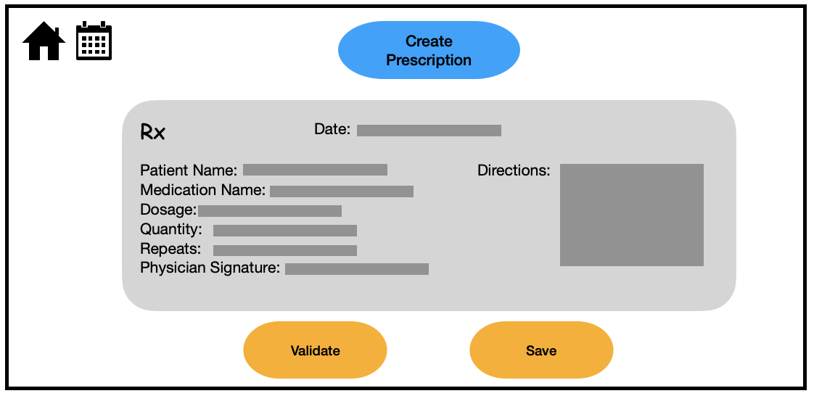
Component ID | Component Name | Data Element ID | Type | Displayed/ Enabled Rules | Label
CO001 | Date |  | Auto-populate | Always Displayed | Date label.
CO002 | Patient Name | BD002 | Drop down | Always Displayed | Patient Name label
CO003 | Medication Name | BD001 | Drop down | Always Displayed | Medication Name label
CO004 | Dosage | BD001 | Character | Always Displayed | Dosage label
CO005 | Quantity | BD001 | Drop Down | Always Displayed | Quantity label
CO006 | Repeats | BD001 | Drop Down | Always Displayed | Repeats label
CO007 | Directions | BD001 | Character | Always Displayed | Directions label
CO008 | Signature |  | Upload image | Always Displayed | Signature label
CO009 | Validate | BD003 | Button | Always Displayed | Validate label.
CO010 | Save | BD003 | Button | Display when prescription is validated | Save label.

UI ID | UI004 | UI/ Screen Name: |  | Enter new pharmacy information
UI Description |  | Form should display all relevant fields to adding a new pharmacy to the system.
UI Screen | 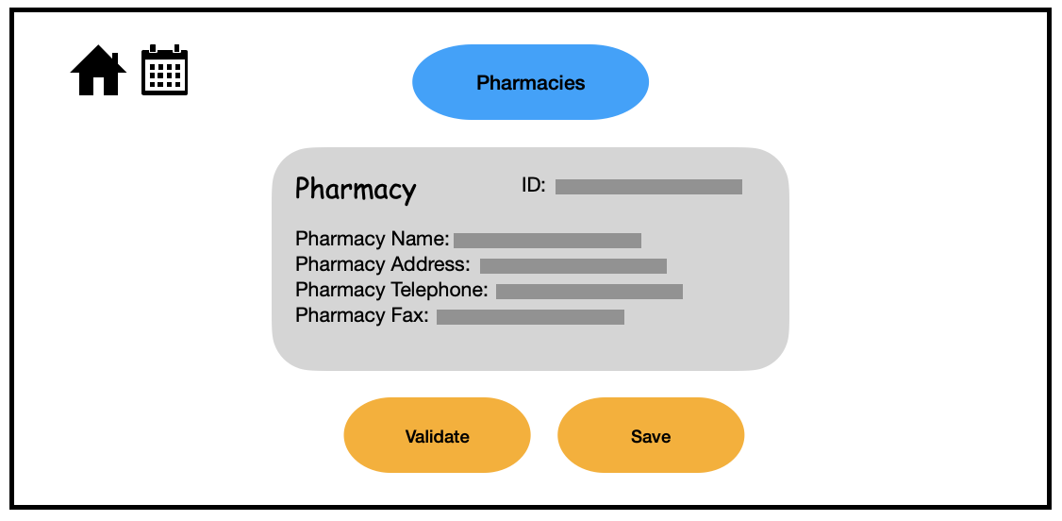
Component ID | Component Name | Data Element ID | Type | Displayed/ Enabled Rules | Label
CO001 | Pharmacy ID | BD006 | Character | Always Displayed | Pharmacy ID label
CO002 | Pharmacy Name | BD006 | Character | Always Displayed | Pharmacy Name label
CO003 | Pharmacy Address | BD006 | Character | Always Displayed | Pharmacy Address label
CO004 | Pharmacy Phone Number | BD006 | Character | Always Displayed | Pharmacy Phone Number label
CO005 | Pharmacy Fax | BD006 | Character | Always Displayed | Pharmacy Fax label
CO006 | Validate | BD003 | Button | Always Displayed | Validate label.
CO007 | Save | BD003 | Button | Display when pharmacy information is validated | Save label.

UI ID | UI005 | UI/ Screen Name: |  | Append Preferred Pharmacy to Patient Profile
UI Description |  | Display should allow physician to add a new preferred pharmacy and also view other preferred pharmacies that have previously been selected for patient.
UI Screen | 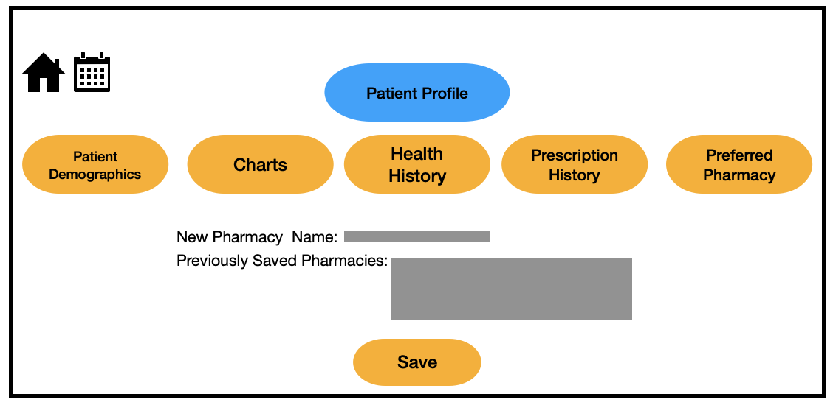
Component ID | Component Name | Data Element ID | Type | Displayed/ Enabled Rules | Label
CO001 | New Pharmacy Name | BD006 | Character | Always Displayed | New Pharmacy Name  label
CO002 | Previously Saved Pharmacies | BD006 | Drop Down | Always Displayed | Previously Saved Pharmacies  label
CO003 | Save | BD003 | Button | Display when all fields are complete. | Save  label

UI ID | UI006 | UI/ Screen Name: |  | Prescription History
UI Description |  | Displays all prescriptions for a patient including those which have not been transmitted and those which have been. Permits Physician to add a preferred pharmacy to the newly created prescription. Physician should also be able to create new prescription as per alt flow.
UI Screen | 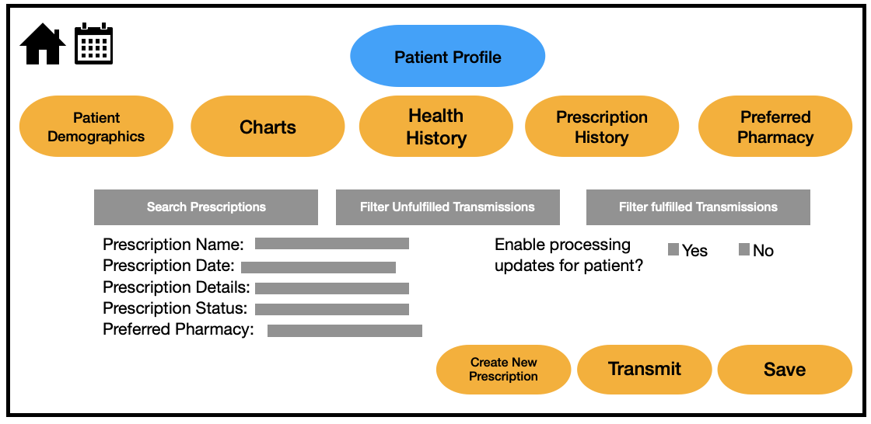
Component ID | Component Name | Data Element ID | Type | Displayed/ Enabled Rules | Label
CO001 | Search Prescription | BD001 | Character | Always Displayed | Search Prescription label
CO002 | Filter unfulfilled transmission | BD001 | Button | Always Displayed | Filter unfulfilled transmission label
CO003 | Filter fulfilled transmission | BD001 | Button | Always Displayed | Filter fulfilled transmission label.
CO004 | Prescription name | BD001 | Character | Always Displayed | Prescription name label
CO005 | Prescription Date | BD001 | Character | Always Displayed | Prescription Date label
CO006 | Prescription Details | BD001 | Character | Always Displayed | Prescription Details label
CO007 | Prescription Status | BD001 | Drop Down | Always Displayed | Prescription Status label
CO008 | Preferred Pharmacy | BD006 | Drop Down | Always Displayed | Preferred Pharmacy label
CO009 | Save | BD003 | Button | Display once Rx is transmitted | Save label
CO010 | Transmit | BD003 | Button | Display once Rx is complete | Transmit label
CO011 | Create New Prescription | BD001 | Button | Always Displayed | Create New Prescription label

UI ID | UI007 | UI/ Screen Name: |  | Prescription Transmission
UI Description |  | Display should permit physician to view all prescriptions created for that day, and transmit all pending prescriptions in one batch
UI Screen | 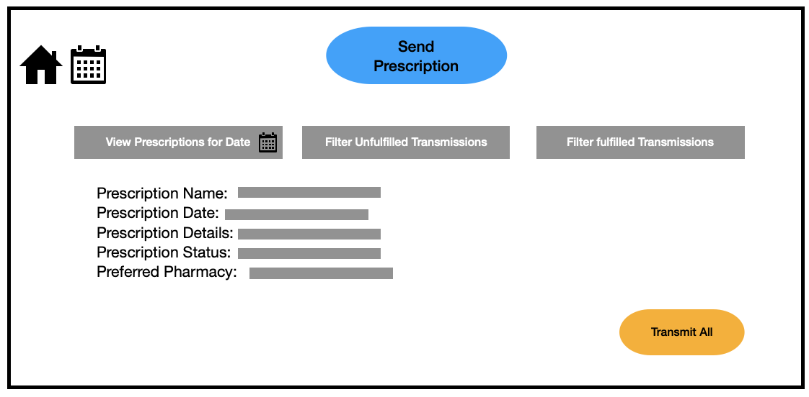
Component ID | Component Name | Data Element ID | Type | Displayed/ Enabled Rules | Label
CO001 | View Prescriptions for Date | BD005 | Character | Always Displayed | View Prescriptions for Date label
CO002 | Filter Unfulfilled Transmissions | BD005 | Button | Always Displayed | Filter Unfulfilled Transmissions label
CO003 | Filter Fulfilled Transmission | BD005 | Button | Always Displayed | Filter Fulfilled Transmission label
CO004 | Prescription name | BD001 | Character | Always Displayed | Prescription name label
CO005 | Prescription Date | BD001 | Character | Always Displayed | Prescription Date label
CO006 | Prescription Details | BD001 | Character | Always Displayed | Prescription Details label
CO007 | Prescription Status | BD001 | Drop Down | Always Displayed | Prescription Status label
CO008 | Preferred Pharmacy | BD006 | Drop Down | Always Displayed | Preferred Pharmacy label
CO009 | Transmit | BD003 | Button | Display when all required fields are complete | Transmit  label

UI ID | UI008 | UI/ Screen Name: |  | Patient Refill Request
UI Description |  | Display should permit patients to request a refill based on their prescription history and receive status notifications regarding the prescription processing
UI Screen | 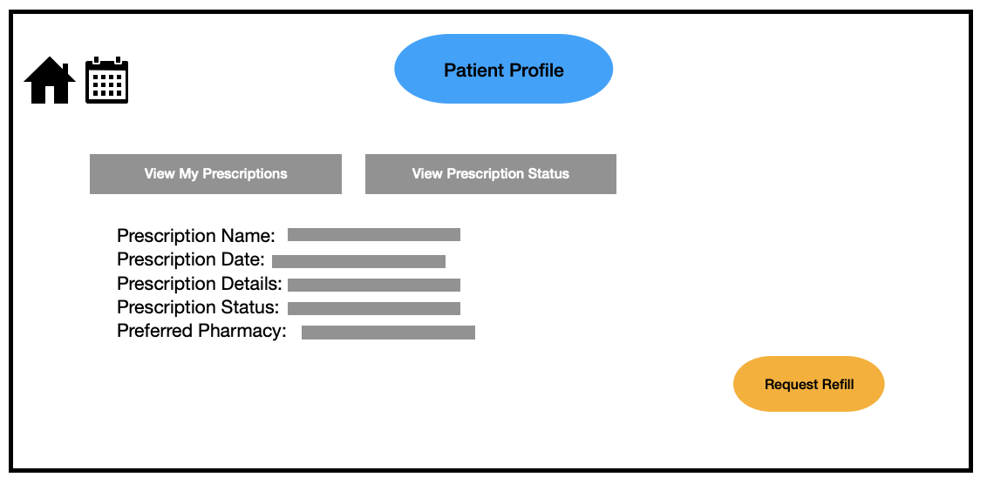
Component ID | Component Name | Data Element ID | Type | Displayed/ Enabled Rules | Label
CO001 | View My Prescription | BD002 | Button | Always Displayed | View My Prescription label.
CO002 | View Prescription Status | BD002 | Button | Always Displayed | View Prescription Status label
CO003 | Prescription name | BD002 | Character | Always Displayed | Prescription name label
CO004 | Prescription Date | BD002 | Character | Always Displayed | Prescription Date label
CO005 | Prescription Details | BD002 | Character | Always Displayed | Prescription Details label
CO006 | Prescription Status | BD002 | Drop Down | Always Displayed | Prescription Status label
CO007 | Preferred Pharmacy | BD006 | Drop Down | Always Displayed | Preferred Pharmacy label
CO008 | Request Refill | BD004 | Button | Display when all required fields are complete | Request Refill label.

Notifications
Summarize the Information presented to a user that summarizes an event, issue, decision, or error.
Not.ID | Notification Name | Notification Trigger | Notification Details | Notification Example | Step(s)  (In Use Case)
NO001 | Missing information | If patient profile is missing demographics or if prescription form is missing a field | Notification informing physician that there is missing information, and the system cannot complete the request until all required information is added | “There is missing information in patient demographics profile, please update and then proceed.”  “Prescription is missing a field, please populate missing information and then save” | 2, 3
NO002 | Potential Risk to Patient | System displays an error message indicating  “potential risk to patient” and prompts for corrective action. | Once prescription is validated, if there are any potential adverse risks to the patient based on their health history, a notification is sent to the physician to review before submitting | “This prescription may be harmful to patient, please reassess before saving” | 4
NO003 | Prescription Submission Confirmation | Successful submission of a prescription request | Confirmation message indicating that the prescription request has been successfully submitted to the system for processing | "Your prescription request has been successfully submitted. You will receive further updates regarding its status." | 13
NO004 | Refill Request Successful | Successful request for a refill | Confirmation to patient indicating that their refill request has been sent to physician successfully | “Your refill request has successfully been sent to your physician for review and approval” | 14

Additional Details & Notes
Please provide any additional details to support this Use Case.

